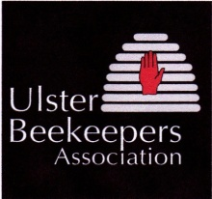 ULSTER BEEKEEPERS’ ASSOCIATION

Peliminary Beekeeping Course 2018

The Preliminary Beekeeping Course will be delivered at locations throughout Northern Ireland by local Beekeeping Associations affiliated to the Ulster Beekeepers’ Association (UBKA) in association with DAERA’s College of Agriculture, Food and Rural Enterprise (CAFRE).
The Preliminary Beekeeping course is an introductory course. It covers the basics of honey bees and beekeeping, setting up an apiary, acquiring bees, hive management, swarm control, disease control and honey production.
The minimum age for candidates participating in the course is 16 years old.
The course will normally run for 10 sessions, one per week, commencing in January/February 2018. There will normally be seven evening classroom sessions followed by three practical beekeeping sessions in an apiary in April/early May when it becomes possible to examine hives and manipulate bees.
The course provides the opportunity of achieving a Preliminary Certificate of Proficiency in Beekeeping, awarded by the Federation of Irish Beekeepers’ Associations (FIBKA).
The course fee is £100 which includes the examination fee.

The contents of the course include:
- Natural history of the honeybee and colony structure.
- Manipulation of a colony of honeybees.
- Hives and frames.
- Siting colonies in an apiary.
- The beekeeping calendar.
- Colony diseases, pests and poisoning.
- Foraging.
- Harvesting honey from the colony.

